a)SERVER SIDE
//Server_hello
#include <iostream>
#include <cstring>
#include <unistd.h>
#include <arpa/inet.h>
int main() {
int server_fd, client_fd;
struct sockaddr_in address;
char buffer[1024] = {0};
const char* reply = "Hello from Server!";
server_fd = socket(AF_INET, SOCK_STREAM, 0);
if (server_fd == -1) {
perror("Socket failed");
return 1;
}
address.sin_family = AF_INET;
inet_pton(AF_INET, "127.0.56.0", &address.sin_addr);
address.sin_port = htons(5000);

if (bind(server_fd, (struct sockaddr*)&address, sizeof(address)) < 0) {
perror("Bind failed");
return 1;
}
if (listen(server_fd, 3) < 0) {
perror("Listen failed");
return 1;
}
std::cout << "Hello Server running on 127.0.56.0:5000\n";
socklen_t addrlen = sizeof(address);
client_fd = accept(server_fd, (struct sockaddr*)&address, &addrlen);
if (client_fd < 0) {
perror("Accept failed");
return 1;
}
read(client_fd, buffer, sizeof(buffer));
std::cout << "Client says: " << buffer << std::endl;
send(client_fd, reply, strlen(reply), 0);
std::cout << "Sent reply to client.\n";
close(client_fd);
close(server_fd);
return 0;
}
a) CLIENT SIDE
//client_hello.cpp
#include <iostream>
#include <cstring>
#include <unistd.h>
#include <arpa/inet.h>
int main() {
int sock = 0;
struct sockaddr_in serv_addr;
char buffer[1024] = {0};
std::string message;
sock = socket(AF_INET, SOCK_STREAM, 0);
if (sock < 0) {
perror("Socket failed");
return 1;
}
serv_addr.sin_family = AF_INET;
inet_pton(AF_INET, "127.0.56.0", &serv_addr.sin_addr);
serv_addr.sin_port = htons(5000);
if (connect(sock, (struct sockaddr*)&serv_addr, sizeof(serv_addr)) < 0) {
perror("Connection failed");
return 1;
}
std::cout << "Enter message to server: ";
getline(std::cin, message);
send(sock, message.c_str(), message.size(), 0);
read(sock, buffer, sizeof(buffer));
std::cout << "Server replies: " << buffer << std::endl;
close(sock);
return 0;
}
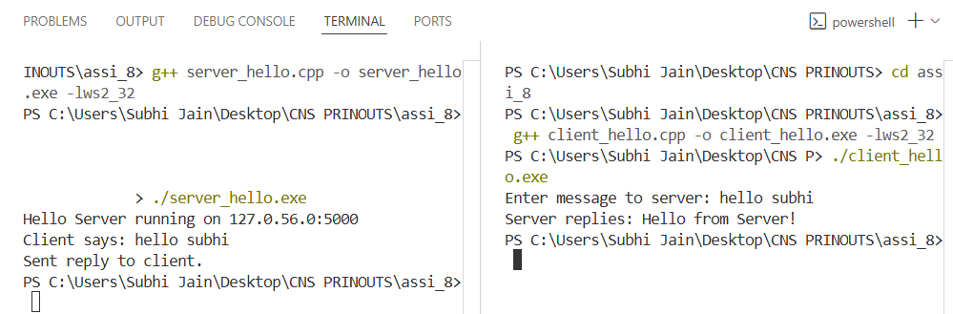
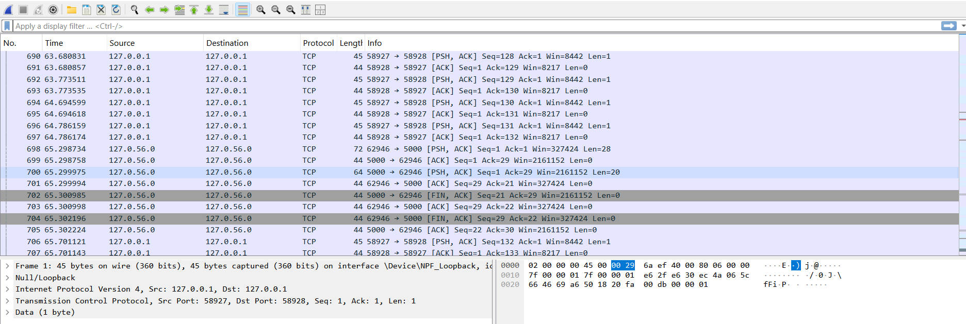

B) SERVER SIDE
//server_file.cpp
#include <iostream>
#include <fstream>
#include <cstring>
#include <unistd.h>
#include <arpa/inet.h>
int main() {
int server_fd, client_fd;
struct sockaddr_in address;
char buffer[4096];
server_fd = socket(AF_INET, SOCK_STREAM, 0);
address.sin_family = AF_INET;
inet_pton(AF_INET, "127.0.56.0", &address.sin_addr);
address.sin_port = htons(6000);
bind(server_fd, (struct sockaddr*)&address, sizeof(address));
listen(server_fd, 3);
std::cout << "File Transfer Server running on 127.0.56.0:6000\n";
socklen_t addrlen = sizeof(address);
client_fd = accept(server_fd, (struct sockaddr*)&address, &addrlen);
// Read filename
char filename[256];
read(client_fd, filename, sizeof(filename));
std::string newFile = "Server_";
newFile += filename;
// Read file size
long filesize;
read(client_fd, &filesize, sizeof(filesize));
std::ofstream outfile(newFile, std::ios::binary);
long received = 0;
while (received < filesize) {
ssize_t bytes = read(client_fd, buffer, sizeof(buffer));
if (bytes <= 0) break;
outfile.write(buffer, bytes);
received += bytes;
}
outfile.close();
const char* msg = "File received successfully!";
send(client_fd, msg, strlen(msg), 0);
std::cout << "Received file: " << filename << std::endl;
close(client_fd);
close(server_fd);
return 0;
}

B) CLIENT SIDE
//file_client.cpp
#include <iostream>
#include <fstream>
#include <cstring>
#include <unistd.h>
#include <arpa/inet.h>
int main() {
int sock = 0;
struct sockaddr_in serv_addr;
char buffer[4096];
sock = socket(AF_INET, SOCK_STREAM, 0);
serv_addr.sin_family = AF_INET;
inet_pton(AF_INET, "127.0.56.0", &serv_addr.sin_addr);
serv_addr.sin_port = htons(6000);
connect(sock, (struct sockaddr*)&serv_addr, sizeof(serv_addr));

std::string filepath;
std::cout << "Enter file path to send: ";
getline(std::cin, filepath);
std::ifstream infile(filepath, std::ios::binary);
infile.seekg(0, std::ios::end);
long filesize = infile.tellg();
infile.seekg(0, std::ios::beg);
std::string filename = filepath.substr(filepath.find_last_of("/\\") + 1);
send(sock, filename.c_str(), filename.size() + 1, 0);
send(sock, &filesize, sizeof(filesize), 0);
while (!infile.eof()) {
infile.read(buffer, sizeof(buffer));
send(sock, buffer, infile.gcount(), 0);
}
infile.close();
char reply[1024];
read(sock, reply, sizeof(reply));
std::cout << reply << std::endl;
close(sock);
return 0;
}
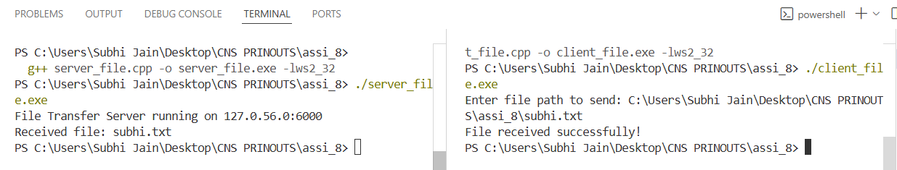
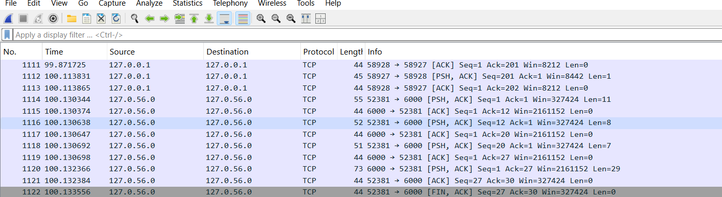

C)SERVER SIDE
//server_calc.cpp
#include <iostream>
#include <sstream>
#include <string>
#include <cstring>
#include <unistd.h>
#include <arpa/inet.h>
double calculate(const std::string& expr) {
std::stringstream ss(expr);
double a, b;
char op;
ss >> a >> op >> b;
switch (op) {
case '+': return a + b;
case '-': return a - b;
case '*': return a * b;
case '/': return b != 0 ? a / b : 0;
default: return 0;
}
}
int main() {
int server_fd, client_fd;
struct sockaddr_in address;
char buffer[1024];
server_fd = socket(AF_INET, SOCK_STREAM, 0);
address.sin_family = AF_INET;
inet_pton(AF_INET, "127.0.56.0", &address.sin_addr);
address.sin_port = htons(7000);
bind(server_fd, (struct sockaddr*)&address, sizeof(address));
listen(server_fd, 3);
std::cout << "Calculator Server running on 127.0.56.0:7000\n";
socklen_t addrlen = sizeof(address);
client_fd = accept(server_fd, (struct sockaddr*)&address, &addrlen);
read(client_fd, buffer, sizeof(buffer));
std::string expr(buffer);
double result = calculate(expr);
std::string reply = "Result: " + std::to_string(result);
send(client_fd, reply.c_str(), reply.size(), 0);
std::cout << "Calculated: " << expr << " = " << result << std::endl;
close(client_fd);
close(server_fd);
return 0;
}
C)CLIENT SIDE
//client_calc.cpp
#include <iostream>
#include <cstring>
#include <unistd.h>
#include <arpa/inet.h>
int main() {
int sock = 0;
struct sockaddr_in serv_addr;
char buffer[1024] = {0};
std::string expr;
sock = socket(AF_INET, SOCK_STREAM, 0);
serv_addr.sin_family = AF_INET;
inet_pton(AF_INET, "127.0.56.0", &serv_addr.sin_addr);
serv_addr.sin_port = htons(7000);

if (connect(sock, (struct sockaddr*)&serv_addr, sizeof(serv_addr)) < 0) {
perror("Connection failed");
return 1;
}
std::cout << "Enter expression (e.g., 5 + 3): ";
getline(std::cin, expr);
send(sock, expr.c_str(), expr.size(), 0);
read(sock, buffer, sizeof(buffer));
std::cout << buffer << std::endl;
close(sock);
return 0;
}

